**Main research questions**

1. Do increasing decision sequences of conjoint choices prime a maximization mindset and decreasing decision sequences of conjoint choices prime a satisficing mindset?

* Compare results on “Self-reported maximizing search goals” and “Subjective happiness scale” between sequences (increasing, decreasing and baseline condition).

1. How is information processing different in increasing, decreasing and baseline decision sequences?

* Compare information processing measures like amount of information processed, search measures, gaze cascades in holdout choices (see below).

1. Do increasing (decreasing) decision sequences of conjoint choices prime a maximization (satisficing) mindset for maximizers as well as satisficers?

* Investigate the interaction effect between “the nature of the goals people pursue in choice situations” (Schwartz (2002), p. 1179, i.e. maximizing or satisficing) and decision sequence (increasing, decreasing and baseline condition).

**Survey design**

**Introductory screen**

We are conducting research on marketing communications. All responses are anonymous and we appreciate your time taken to complete this survey.

Thank You!

Please enter the same provided identification number used on the eye tracking machine

___

**Six item maximizing scale from Nenkov et al. (2008) – follow up paper of Schwartz et al. (2002):**

*Randomize order of items*

We’d like to start with some general statements about how you behave in daily situations.

Please indicate your degree of agreement with the following statements (-3 = I do not agree with the statement at all, +3 = I agree with the statement very much)

* When I am in the car listening to the radio, I often check other stations to see if something better is playing, even if I am relatively satisfied with what I’m listening to.
* No matter how satisfied I am with my job, it’s only right for me to be on the lookout for better opportunities.
* I often find it difficult to shop for a gift for a friend.
* Renting videos is really difficult. I’m always struggling to pick the best one.
* No matter what I do, I have the highest standards for myself.
* I never settle for second best.

**5 item regret scale from Schwartz et al. (2002):**

*Randomize order of items*

The following statements are related to choices in daily situations.

Please indicate your degree of agreement with the following statements (-3 = I do not agree with the statement at all, +3 = I agree with the statement very much)

* Whenever I make a choice, I’m curious about what would have happened if I had chosen differently.
* Whenever I make a choice, I try to get information about how the other alternatives turned out.
* If I make a choice and it turns out well, I still feel like something of a failure if I find out that another choice would have turned out better.
* When I think about how I’m doing in life, I often assess opportunities I have passed up.
* Once I make a decision, I don’t look back.

**Purchase experience and purchase intention:**

Let’s come to a different topic now:

When was the last time you booked a vacation package?

* Within the last 12 months
* Between the last 12 and 36 months
* Longer than 36 months ago
* I never booked a vacation package before.

Are you planning to book a vacation package within the next 12 months?

* Yes
* No

When it comes to booking a vacation package, what would you say: How long do you search for information before you decide which vacation package to book?

* Less than one week
* Between one and two weeks
* More than two weeks

**Purchase familiarity and involvement (based on Foote, Cone, and Belding Involvement (FCBI) subscale, Ratchford (1987):**

* Overall, how familiar are you with booking vacation packages?

-3: very unfamiliar to +3: very familiar

What would you say:

* The decision which vacation package to buy is a

-3: very unimportant decision to +3: very important decision

* The decision which vacation package to buy

-3: requires little thought to +3: requires a lot of thought

* When booking a vacation package there is

-3: little to lose if you choose the wrong package to +3: a lot to lose if you choose the wrong package

**Explanation of the preference measurement design to the respondent:**

Assume a rich relative has just given you $1000 to go on vacation for you and a friend. The place you have chosen has many exciting things for you to do and see. You now need to consider the place at which you will stay. On the following screens you will see sets of vacation packages you can choose from. Each decision you make should be treated like an actual purchase.

Consider these vacation packages as possible options for a forthcoming weekend holiday. You have already selected your destination but still need to book your accommodation. The following pages will show different accommodation options. For each page select your most preferred option. Each page shows a new selection, each time you can choose only one option.

Please have a careful look on the following features before you start choosing: We will need to elaborate on these attributes so that the choice is realistic.

**Food quality** (one, two or three stars)

**Customer service rating** (Low, Medium, High)

**Type of building** (Bungalow, Rooming house, Hotel complex)

**Sea view** (No sea view, Side sea view, Full sea view)

**Price** ($499, $399, $299)

**Room category** (Standard, Superior, Deluxe)

**CBC-Question:**

If you were in the market to buy a vacation package today and these were your only options, which would you choose?

**Decision Sequence**

* ***4 conditions****:* 
  + *Increasing condition: Decision sequence including an increasing complexity of the choice tasks (from 2 alternatives to 8 alternatives)*
  + *Decreasing condition: Decision sequence including a decreasing complexity of the choice tasks (from 8 alternatives to 2 alternatives)*
  + *Baseline condition 1 in which respondents see 7 choice tasks with an equal number of 8 alternatives.*
  + *Baseline condition 2 in which respondents see 7 choice tasks with an equal number of 2 alternatives.*
* *Choice tasks in the increasing and decreasing condition therefore include 2, 3, 4, 5, 6, 7 or 8 alternatives. We show only one choice task for each complexity level. In the increasing and decreasing condition, respondents will see the same amount of alternatives throughout the experiment, i.e. 1*2+1*3+1*4+1*5+1*6+1*7+1*8=35 alternatives.*
* *Alternatives are described by using 6 attributes with 3 attribute levels each (see above)*
* *Random choice tasks are generated by using the complete enumeration algorithm from Sawtooth Software.*

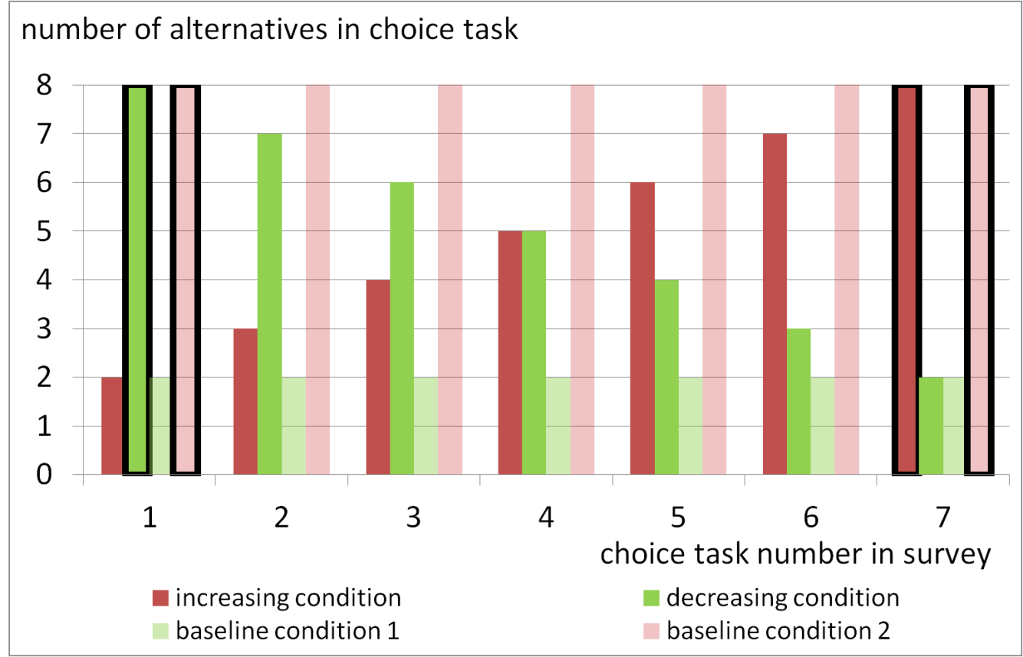

***Intuition of the design:***

***The following difference:***

***Duration (CT7, increasing cond., 8 alternatives) – duration (CT1, decreasing cond., 8 alternatives)***

***depends on two factors:***

***a) learning during the conjoint interview***

***b) difference when being in a maximizing or satisficing mindset.***

***We are interested in b) and want to eliminate the effect of a). This is why we need the baseline condition 2. From that data we can estimate the effect of a) learning during the conjoint interview:***

***Duration (CT 7, baseline 2, 8 alternatives) – duration (CT1, baseline 2, 8 alternatives)***

*Using baseline condition 1, we can do the same with respect to the two alternatives when comparing the increasing condition with the decreasing condition.*

**Holdout task 1 (Rating based conjoint)**

Respondents rate 8 product profiles on 11-point rating scale: Definitely reject (0) …..Definitely accept (10)

*Question:*

*Thank you for your choices, now indicate how likely it would be that you would choose the following alternatives?*

**Holdout task 2 (Transit choice) -> see power-point slides**

Now imagine that a relative is coming to Melbourne for a weekend. He/she likes to find a hotel which is both, nearest to the airport and also the cheapest.

Below you see six different offers from hotels in and around Melbourne. By clicking on those offers you can get more information about them. Please click on the hotel you would recommend to your friend.

**Self-reported maximizing search goals from Levav et al. (2012):**

Let’s come back to vacation packages:

*Randomize order of items*

Please indicate your degree of agreement with the following statements (-3 = I do not agree with the statement at all, +3 = I agree with the statement very much)

* Even if I found a vacation package that I was relatively satisfied with, I still looked to the other available vacation packages before deciding.
* I tried to find the best vacation package in each of the previous choice task.
* I had in mind some ideal vacation package(s), and I tried to look for vacation packages similar to my ideal package(s).
* I made my decision in each choice task as soon as I found a vacation package that was good enough.

**Subjective happiness scale from Lyubomirsky and Lepper (1999):**

*Randomize order of items*

For each of the following statements and/or questions, please mark the point on the scale that you feel is most appropriate in describing you.

* In general, I consider myself:

(-3: not a very happy person, +3: a very happy person)

* Compared to most of my peers, I consider myself:

(-3: less happy, +3: more happy)

* Some people are generally very happy. They enjoy life regardless of what is going on, getting the most out of everything. To what extent does this characterization describe you?

(-3: not at all, +3: a great deal)

* Some people are generally very happy. They enjoy life regardless of what is going on, getting the most out of everything. To what extent does this characterization describe you?

(-3: not at all, +3: a great deal)

**Gender**

Youare…

* Female
* Male

**Age**

How old are you?

____

Thank you very much for participating in this study!